How to unleash your creative potential with Scrivener

**What is Scrivener?**

[Scrivener](https://www.literatureandlatte.com/scrivener/overview) is a powerful tool for producing pieces of creative writing such as short stories, dramas and even full-length novels. It facilitates the process of writing by providing a writer all the necessary tools of the trade, from the ability to conveniently file the complex character descriptions to attaching goals to every writing session or choosing a visual theme according to one’s own liking.

In this manual we will focus on the step that precedes the process of writing itself – on choosing a writing template that suits your creative goals best.

Intrigued?

Follow the instructions and you will be able to start working on your own writing project in no time.

**First step**

After launching Scrivener, you will find yourself on a starting page. To set up your first writing project find and click on the menu bar option “File” in the upper-left corner of the window. Then select “New Project…”You can also use the preset hotkeys instead: press either Ctrl+G or Ctrl+N to instantly call up the project creation window.

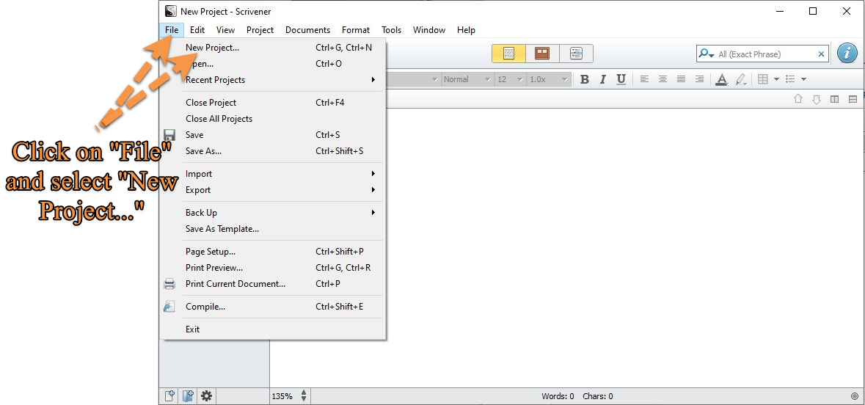

**More tutorials**

From the newly opened project creation window you can see that the list of writing options is topped by “Getting Started” which provides the comprehensive in-depth Scrivener manual that encompasses all the available features of the program. There is also a possibility to walk through an interactive manual so as to build a better muscle memory in using Scrivener.

**Types of creative writing to do with Scrivener** 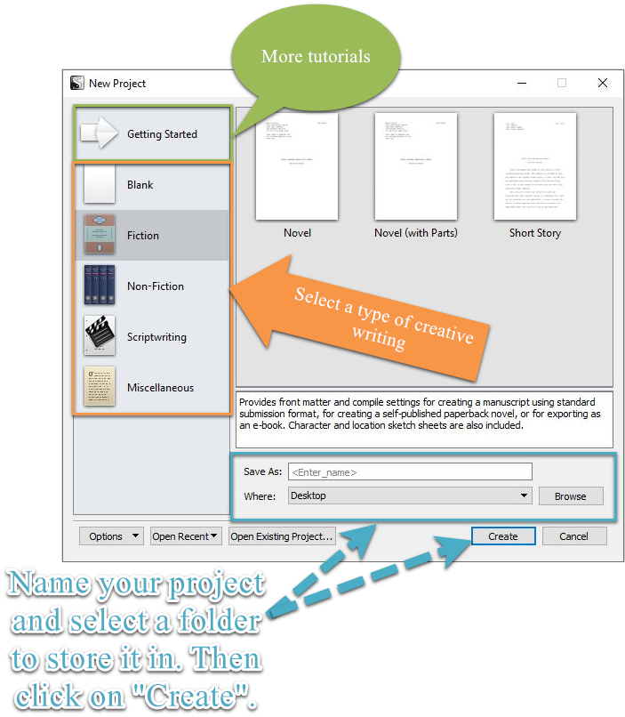

There are five types of creative writing that you can currently do with Scrivener. These are:

* **Blank.** Provides but a blank sheet of paper and a subfolder to store the results of your research in.Suitable for writing an essay or for creating a blog post.
* **Fiction.** Offers three options for writing a piece of fiction. Choose the one that answers your particular needs:

1. **Novel.** Provides front matter and compile settings for creating a manuscript using standard submission format, for creating a self-published paperback novel, or for exporting as an e-book. Character and location sketch sheets are also included.
2. **Novel (with Parts).** Provides a title page and compile settings for creating a manuscript using the standard format for novel submissions. Character and location sketch sheets are also included. This template is designed for novels that are broken into parts as well as chapters.
3. **Short Story.** Provides a first page header and compile settings for producing a standard manuscript suitable for short story submissions. Character and location sketch sheets are also included.

* **Non-Fiction.** Again, there are three options for writing a work of non-fiction. These include:

1. **Non-Fiction (with Sub-Heads).** Provides a title page and compile settings for creating a non-fiction manuscript with in-chapter sub-heads.
2. **Research Proposal.** This template is designed to produce a standard 15-page research or thesis proposal.
3. **Undergraduate Humanities Essay.** Provides a project structure and compile settings suitable for creating an undergraduate humanities essay.

* **Scriptwriting.** Scrivener offers a wide variety of scriptwriting opportunities:

1. **BBC Radio Scene Style.** BBC format for radio.
2. **BBC Taped Drama.** BBC format for taped drama series.
3. **Comic Script.** A comic script template provided by graphic novel and comics writer Antony Johnston.
4. **Screenplay.** A template project set up for writing Hollywood screenplays ready for printing directly or exporting to Final Draft.
5. **Stage Play (UK).** Provides the title page, compile settings and structure for creating UK stage play manuscripts.
6. **Stage Play (US).** Provides the title page, compile settings and structure for creating US stage play manuscripts.

* **Miscellaneous.** Allows to organize two other types of writing, i.e.:

1. **Persuasive lecture.** Provides a manuscript outline for a motivational or persuasive lecture.
2. **Recipe collection.** Provides a cookbook-style binder to organize your digital recipes and cooking resources; includes a rating system and color-coded prep and cook time labels.

From this wide variety of creative writing options, choose the one that is right for you. Be aware of the fact that before finishing the process of creating a template for your project you are ought to name it and to select a folder where it will be stored. To complete the process of creation, click on the “Create” button in the bottom right corner of the window.

Voila, you are ready to embark on your creative journey in just a few clicks.

Simple, isn’t it?

**Try it yourself**

[Download Scrivener](https://www.literatureandlatte.com/scrivener/download) from our website and start your journey as a writer right away.

In case you still have any questions or difficulties after completing this manual, please, pay a visit to our [forum](https://www.literatureandlatte.com/forum/index.php). We would be glad to assist you anytime.

### Stay tuned to find out more

In our next manual, “How to create best-selling novels with Scrivener” we will focus on writing tools that will dramatically promote the efficacy of your writing process and the quality of your works. Stay in touch with us and become a writer that is second to none.